EConDA Obesity and Smoking Tools:

User Guide

Contents
EConDA Obesity and Smoking Tools: 2
User Guide 2
Background 4
Installing the program 5
Running the simulation 6
1. Risk factor selection 6
2. Setup 6
3. Run length of the simulation 7
4. Select a cohort 8
5. Select an intervention 9
6. Input intervention and baseline costs and Discounting rates 10
7. Sensitivity Analysis on Intervention cost 10
8. Input disease costs 10
9. Running the cohort 12
Interpreting the outputs 13
10. Output: Prevalence and Prevalence by stage 13
11. Output: Diseases 14
12. Graphics 15
13. Output: Intervention Effectiveness 17
14. Costs: Input and Output 18
15. Output Files 18
16. Additional features: The menu bar 19
Appendix 1: Glossary of terms 20
Appendix 2: How are costs calculated? 20

Background

The EConDA project – ‘Economics of Chronic Diseases’ is considering recommendations for integrated interventions, performing an economic evaluation of the investment required, expected outcome and possibility for scaling up/transferring experiences across Europe.
The key aim of the project is to aid EU Member States to develop, select and implement more cost-effective policies to improve chronic disease prevention and impact upon populations with the highest rates of premature deaths from chronic diseases and reduce health inequalities.

The specific objectives of the EConDA project are to:
- Seek consensus among relevant experts, policy makers and international organisations on the methodology for measuring cost-effectiveness of interventions to prevent, screen and treat chronic diseases.
- Develop a demonstration model for integrated approaches to address cost-effectiveness of various interventions for chronic disease prevention, screening and treatment.

As part of the project a downloadable tool has been developed for use by policy makers and researchers to test the cost-effectiveness of a range of interventions. In particular the aims of the tool are to:

- Project the incidence and prevalence of BMI related and smoking related chronic diseases forward to 2050. The diseases included are coronary heart disease (CHD), stroke, hypertension, type 2 diabetes (obesity only), chronic kidney disease (CKD) and chronic obstructive pulmonary disease (COPD, smoking only).
- Estimate the direct health and non-health related costs avoided, following effective interventions to prevent, screen or treat these diseases.

The EConDA project – ‘Economics of Chronic Diseases’ [http://econdaproject.eu]

This tool arises from the project EConDA which has received funding from the European Union in the framework of the Health Programme

Installing the program

- Download and run EConDA_Tool_Setup.exe
- Select where you want to install the program and click Next.
(If you set this to “Program Files”, you will need to run the program with admin privileges every time you start it.)
- Select whether you want shortcuts placed on the desktop and click Install.

After the program is installed, you will find shortcuts in your Start menu under “EConDA Tool”.
There will be shortcuts for both running the tool and for opening the output folder.
If you have selected to have shortcuts on your desktop, there will be shortcuts for the tool and the output folder.

When you first run the program, you will be prompted to accept the licence agreement. Please read over the terms and conditions then click Agree.
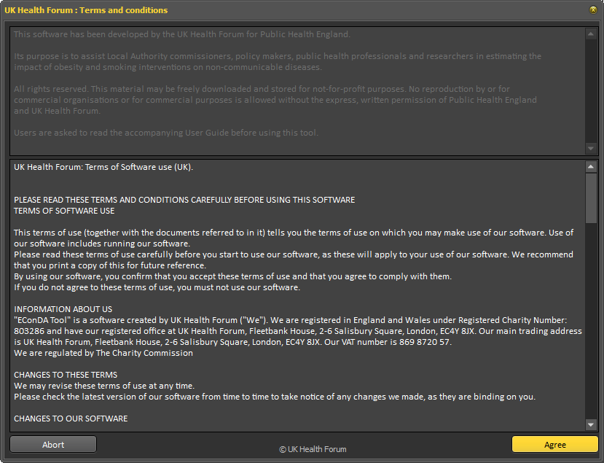

Running the simulation

1. Risk factor selection
When you start the tool, select whether you want to run scenarios for either obesity or smoking.
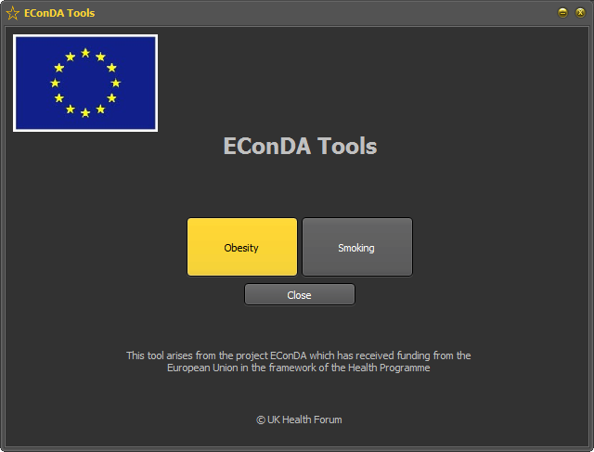

2. Setup
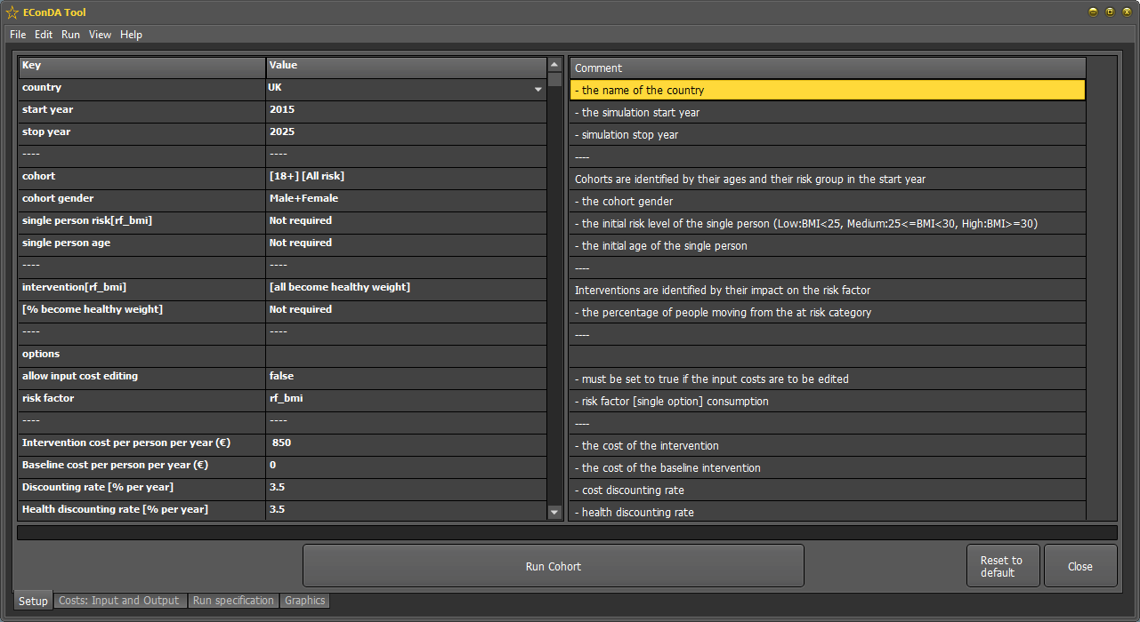
The set page is divided into 3 parts: 1st column is the key, 2nd contains the values / parameters which the user can adjust and 3rd is built-in comments to guide the user.
On the main ‘setup’ page, use the drop down menu to select the country that you wish to run.
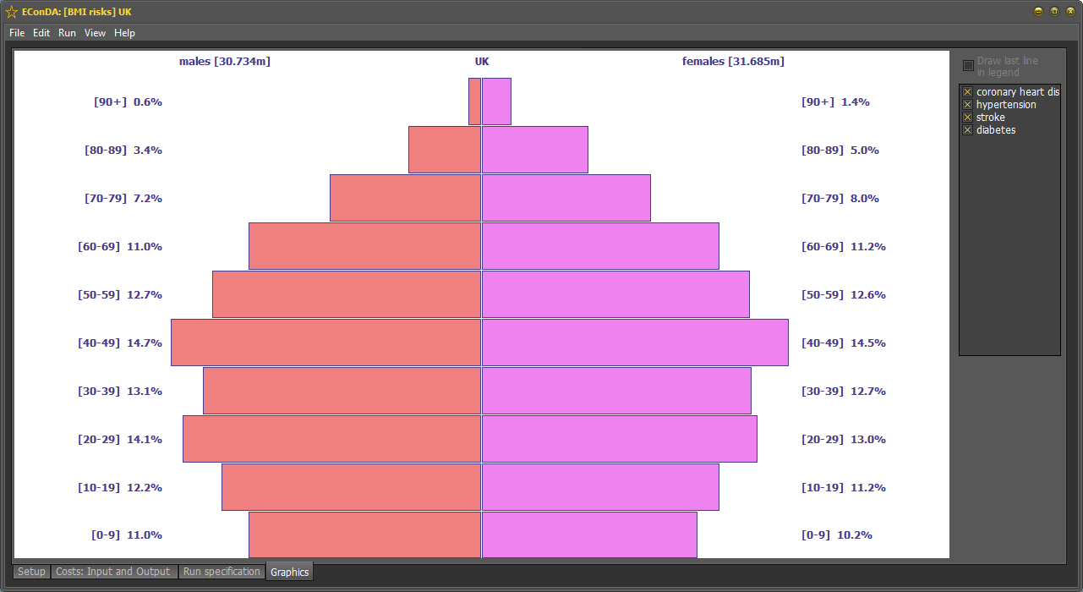
Note: Within the tool there is an option to display the age distribution of the population in your country of interest. Select ‘view’ in the main toolbar, and choose the desired ‘population pyramid’ to display. UK is displayed as an example below:

This shows the total number of males and females in the country of interest and how they are distributed by age throughout the population. (to come back to the set-up menu, select the set-up tab)

3. Run length of the simulation
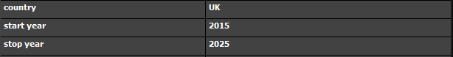
Select the start and stop year for the simulation using the drop down menu. For example, you can run the simulation starting in 2015 and end it in 2025. You can also select “last person dead” which result to all the individual in the cohort being dead.

4. Select a cohort
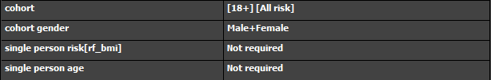
Choose the cohort that you would like. There are two options:

- Cohort:
Select the age boundaries of the cohort:
- 18+ (all risk) – This refers to all adults in the country who are above the age of 18 years old, regardless of their risk.
- 18-39 (all risk) - This refers to all adults in the country who are 18-39 years old, regardless of their risk.
- 40-64 (all risk) - This refers to all adults in the country who are 40-64 years old, regardless of their risk.
- 65+ (all risk) - This refers to all adults in the country who are 65 years or above, regardless of their risk.
- 18+ (at risk) - This refers to all adults in the country who are above the age of 18 years old and are ‘at risk’ (obese or smoker depending on the risk factor).
- 18-39 (at risk) - This refers to all adults in the country who are 18-39 years old and are ‘at risk’ (obese or smoker depending on the risk factor).
- 40-64 (at risk) - This refers to all adults in the country who are 40-64 years old and are ‘at risk’(obese or smoker depending on the risk factor).
- 65+ (at risk) - This refers to all adults in the country who are 65 years old or above and are ‘at risk ‘(obese or smoker depending on the risk factor).
- Single person:
Select the age of the individual, and the risk of interest:
- Low risk/never smoked, corresponding to ‘BMI < 25’ or having ‘never smoked’.
- Medium risk/ex smoker, corresponding to ‘BMI 25-29.9’ or having previously smoked but since given up.
- High risk/smoker, corresponding to ‘BMI ≥ 30’ or ‘actively smoking’.
You may wish to select a single person, rather than a cohort, in order to determine the risk of disease to an individual as a result of being obese or a smoker. For example, you may wish to analyse a range of trajectories of risk for a 20-year old male throughout his life. You can assign their level of risk e.g. low risk (BMI < 25). It works by creating copies of a single person to make a cohort.
Note: ‘At risk’ is assumed to be individuals who have a BMI ≥ 25 or smoked at some point/are smokers. The distributions of the three levels of the risks, low/never smoked, medium/ex-smoker and high/smoker, are based on current distributions in the country. You can also specify the gender of the cohort (it is set to analyse both females and males by default, but you can specify the programme to only produce outputs for a particular gender). If a cohort is selected the single person attributes are automatically set to Not required.
5. Select an intervention
For obesity, you can select one of the following interventions:
- ‘No change’ – trends continue as expected with no intervention i.e. baseline.
- ‘All become healthy weight’ – everybody in the population reduces their BMI to <25.
- ‘% becomes healthy weight’ - A given percentage of the population reduces their BMI to <25 e.g. 25% of overweight/obese individuals move to the BMI < 25 category
- Sugar Sweetened Beverage tax. The main assumption to model SSB tax is the following: A 20% excise tax on SSB will have an impact of 3% on obesity prevalence. (Smith TA et al, 2010)
- Multi Component Lifestyle Intervention: the following assumptions have been used:
- 12% of obese persons take up a MCLI when offered it by their General Practitioner or Family Doctor
- 87% of those who start a MCLI complete it
- Only obese individuals (BMI≥30) will be offered an intervention
- Intervention successful for the remaining 87%*12%=10.44%

For smoking, you can select one of the following interventions:
- ‘No change’ – trends continue as expected with no intervention i.e. baseline.
- ‘All become non smoker’ – everybody in the population changes to an ex-smoker.
- ‘% becomes non smoker’ - A given percentage of the population changes to an ex-smoker e.g. 25% of overweight/obese individuals move to the ex-smoker category.
- Smoking Cessation Intervention: the following assumption is made to model Tobacco Cessation Intervention: introducing the Smoking cessation intervention to the entire population in the UK will result in the reduction of smoking prevalence by 6.9% (63% x 11% = 6.9%) 12 months later. This is based on the 52-week continuous abstinence intervention.

6. Input intervention and baseline costs and Discounting rates
To carry out health economy analyses, the intervention and baseline (cost if no intervention is applied) costs are required.
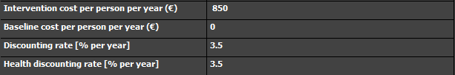
Cost and health discounting rates can be chosen as well.

7. Sensitivity Analysis on Intervention cost
A sensitivity analysis on intervention cost can be carried out ie, what would be the ICER if we were to increase the intervention cost by x %. The percentage change can be chosen in the set-up menu. Note that the output of the sensitivity analysis is shown in the summary and cost effectiveness analysis tab.

8. Input disease costs
The programme uses direct health and non health costs for each disease, adjusted for country population.
To input your own costs, firstly select “Run > initialise run” in the menu to load the costs from the disease files then select the ‘costs: Input and Output’ tab. This is the second tab sheet at the bottom of the page. The input box will only accept numbers 0-9 and a single decimal point.

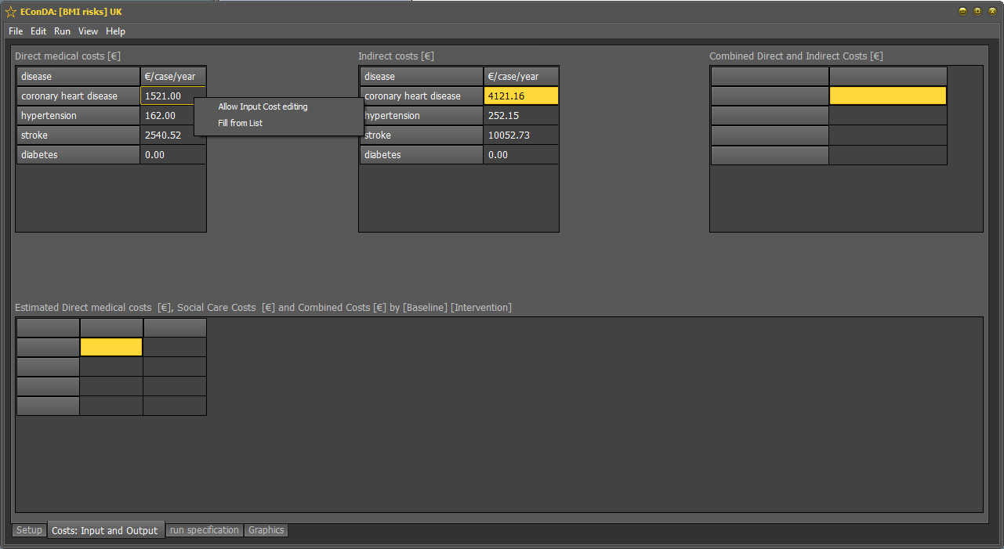
Right click on the costs and select the option for ‘allow input cost editing’ if you would like to edit the cost inputs (this sets it to ‘true’ to allow editing by inserting a √). Select it again if you would like them to remain as the input costs (the √ will disappear). This is set to ‘true’ by default.
Costs: Inputs and Output
Right click to edit costs

9. Running the cohort
Once you are happy with the setup in the setup tab, click ‘Run Cohort’ on the main setup page or in Run\Run Cohort. This will run the simulation. (You can reset the simulation by closing the window and select again the risk factor of interest)
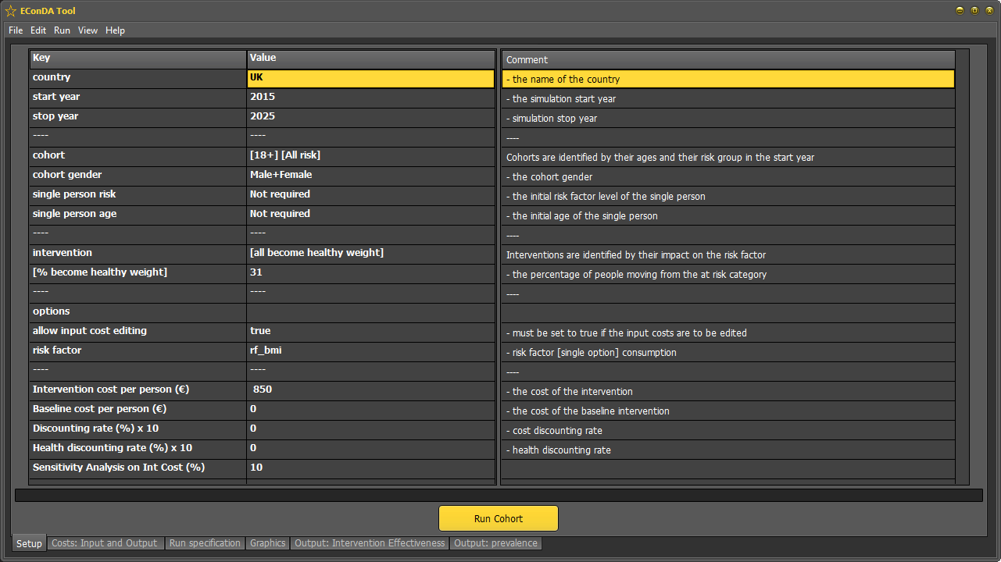
Run Cohort
Setup

Interpreting the outputs

Once the tool has run, the output tabs will appear along the bottom of the page:

10. Output: Prevalence and Prevalence by stage
The user should be able to see three tables in either output prevalence or output: prevalence by state depending if the batchfile includes diseases by stage or single state disease:

- ‘Baseline’: The number of people surviving in the cohort and the number of disease cases by year.
- ‘Intervention’: The number of people surviving in the cohort and the number of disease cases by year.
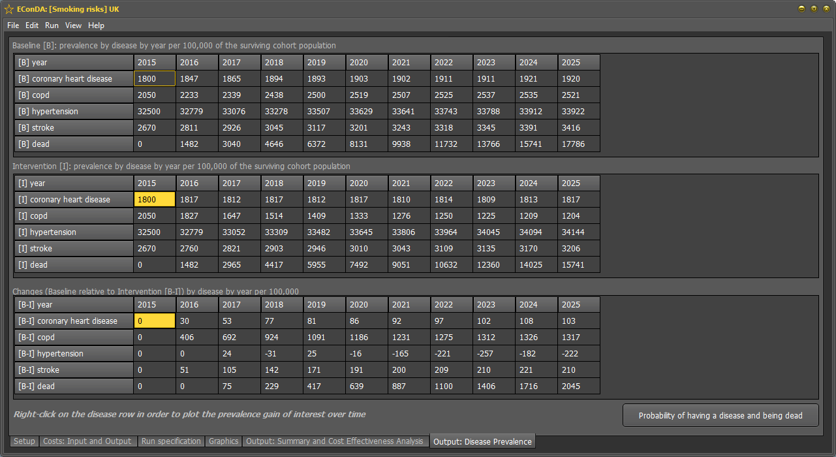
- ‘Changes’: The changes in the numbers in the cohort and the numbers of disease cases by year. Right clicking on a specific disease in this table and selecting ‘Draw Selected Disease [cases by year]’ will enable the user to plot changes in this disease for each year of the model simulation.
Output: Prevalence

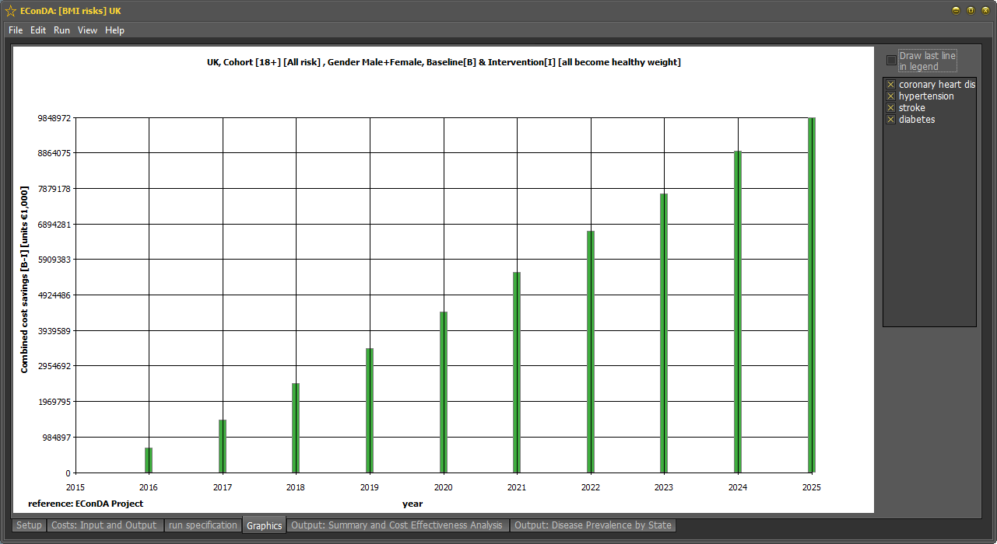
11. Output: Diseases
This is accessed by clicking the “Probability of having a disease and being alive” button under Output: Prevalence.
The user should be able to see two tables:
- ‘Cohort baseline’: The annual mean probability of being alive and to have a disease or to die.
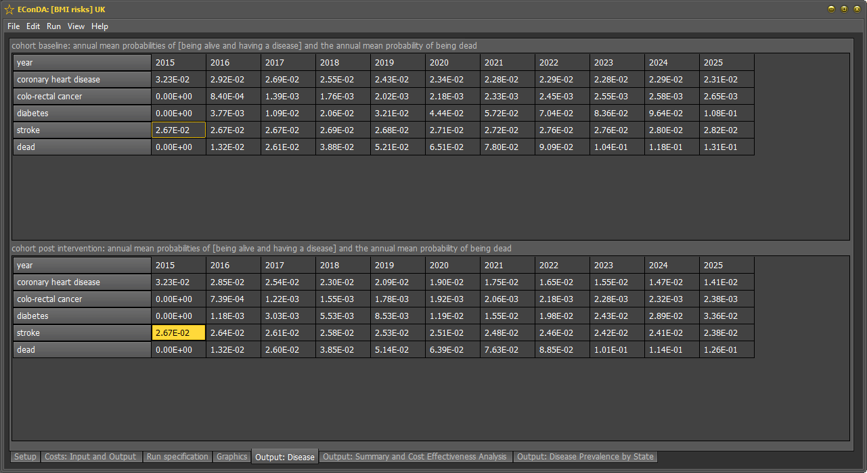
- ‘Cohort post intervention’: The annual mean probability of being alive and to have a disease or to die.
Output: disease
12. Graphics
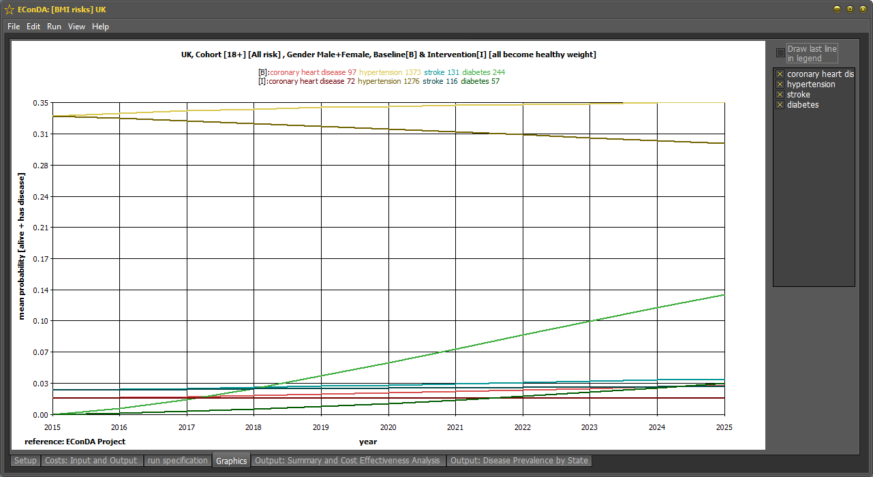
This following graph shows the year along the x-axis and the probability of being alive and having a disease on the y-axis. The diseases are listed at the top of the graph with average number of expected disease days per person throughout their life.
Baseline
Intervention
Year
Disease days
Probability of having the disease
Graphics

How to interpret the graph
At baseline, the average number of disease exposure days for diabetes is 319 and coronary heart disease is 33 per person.
Following the intervention, (all become active), the average number of disease exposure days for diabetes is 225 and coronary heart disease is 22.

How to make changes to the graph
You can ‘right click on this graph:
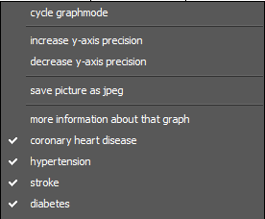
This allows you to:
- Cycle graph mode – to cycle through different types of graphics.
- Increase or decrease the precision of the y-axis.
- Save the graph as a jpeg file to use the pictures in your reports.
- Take out diseases so that you can view other diseases on a more readable scale.
You can also use the list to the right side of the graph to change what diseases are shown.

13. Output: Intervention Effectiveness
This tab shows the analysis of the selected intervention that was run. You can see:
- Cost parameters such as: Baseline and intervention disease cost, Intervention cost
- QALY parameters such as: Baseline and Intervention QALYs
- Life expectancy and DALYs
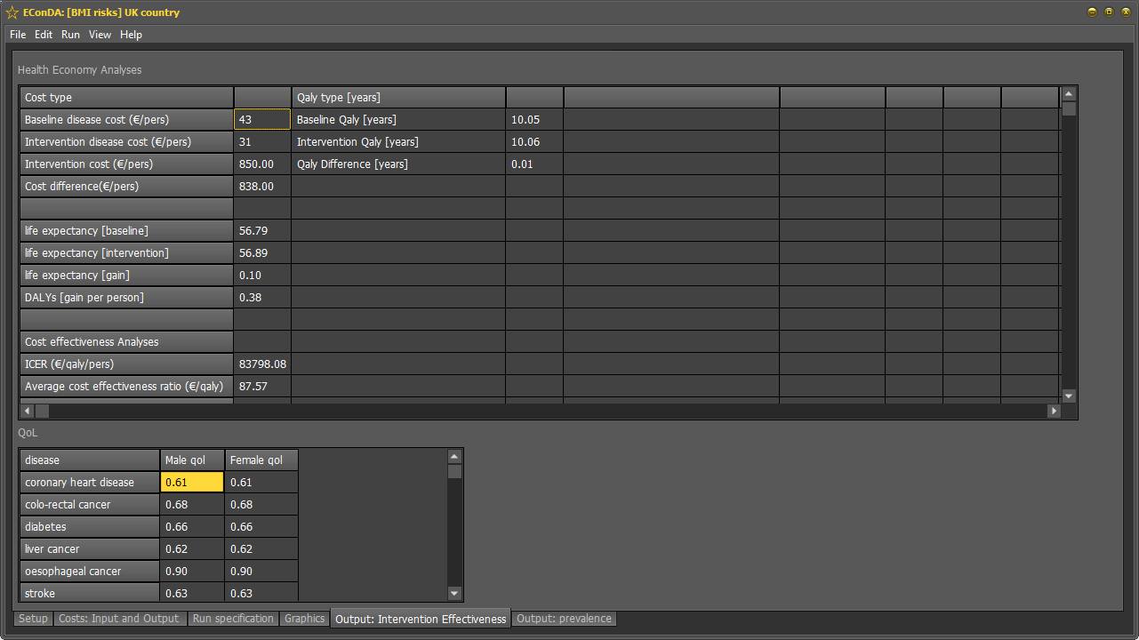
- Cost effectiveness parameters such as: ICER, average cost effectiveness ratio

14. Costs: Input and Output
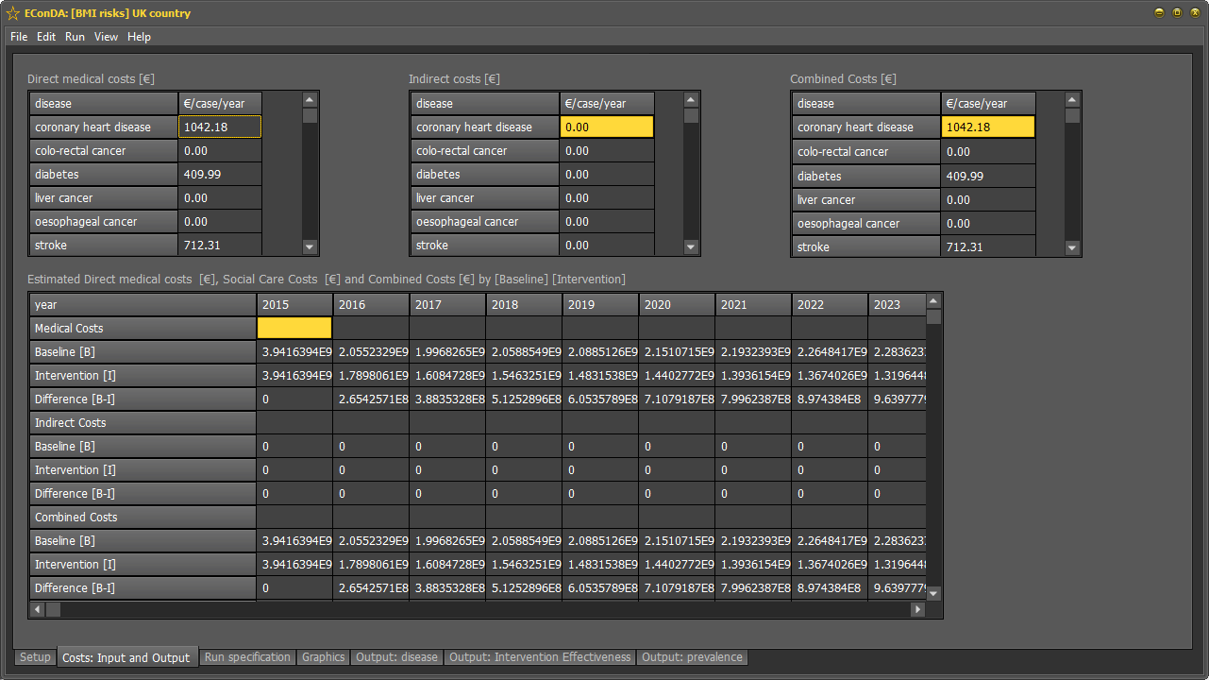
In the same tab where you inserted costs, you can now view the cost output over the course of the simulation.

15. Output Files
All the outputs are saved in the output folder under the country and time and date of the run. You can access the output folder by opening the Output Folder shortcut from the start menu under All Programs > EConDA Tool or from the shortcut on the Desktop if you enabled this during installation.
- The counts by year can be found in the text file called: BaseCounts.txt
- The prevalence of the baseline scenario can be found in the text file called: BasePrev.txt
- The costs for the baseline and intervention by year can be found in Costs.txt
- The change in costs by year can be found in DiffCounts.txt
- The effectiveness of the intervention can be found in Health_Economy.txt
- The intervention costs can be found in IntCounts.txt
- The prevalence for the intervention can be found in IntPrev.txt
- The medical costs of each disease can be found in MedCosts.txt
- The social care costs of each disease can be found in SocCosts.txt
- The summary of the run (DALYs, life expectancy etc.) can be found in summary.txt

16. Additional features: The menu bar
There are a number of additional features that can be selected from the menu bar:

- File/Open Output Folder – this will open the folder where the output files are saved.
- File/Quit – this will close the application.
- Edit/Setup - once you have run the simulation you can go back to the initial set up page by selecting this option.
- Edit/Clear Output - once you have run the simulation this will delete all of the outputs from any previous runs you have done.
- Run/initialise run - this gives you an overview of the initialisation components that you specified in the previous 4 steps above.
- Run/run cohort – this runs the simulation in the same way as the ‘run cohort’ button on the main setup screen.
- View/population tree – this allows you to view the population distribution of all ages, or specific age groups in the selected local authority.
- View/draw disease prevalence by year – selecting this will bring up a graph of the disease prevalence.
- View/draw cost savings by year.
- View/draw cumulative cost savings by year.
- View/Increase font size – this will make the font bigger across the tool.
- View/Decrease font size – this will make the font smaller across the tool.
- View/Swap to light mode – this will switch the tool to the light theme.
- View/Swap to dark mode – this will switch the tool to the dark theme.
- Help – this contains the user guide, glossary of terms and the method used for deriving costs.

Appendix 1: Glossary of terms
- Baseline – This refers to the ‘steady state’ of the risk factor. A scenario where no intervention occurs and trends continue unabated.
- Data pack - This is a single file which contains all of the disease and population statistics required by the tool.
- Disease exposure – this refers to the number of days per person that an individual has a disease. For example, 500 diabetes days refers to the number of days an individual is alive and lives with a disease.
- Distribution –the frequency of various outcomes in a sample population. The frequency or count of the occurrences of values within a particular group or interval, and in this way, the table summarizes the distribution of values in the sample.
- Incidence – the occurrence of new cases of the disease – not to be confused with prevalence.
- Prevalence – this is the total number of cases of a disease in a particular population. This indicates how widespread the disease is.
- Probability – this is the chance of a disease occurring. Probability always lies within 0 and 1.
- Simulation – the imitation of a real-world process or system over time, in this case the simulation of a virtual country population.

Appendix 2: How are costs calculated?
Following the simulation run, the programme simply scales the aggregated individual disease costs according to the relative disease prevalence in years after the start year.
In any year, the total healthcare cost for the disease D is denoted C_{D}(year). If the prevalence of the disease is denoted P_{D}(year) we assume a simple relationship between the two of the form
for some constant κ.

